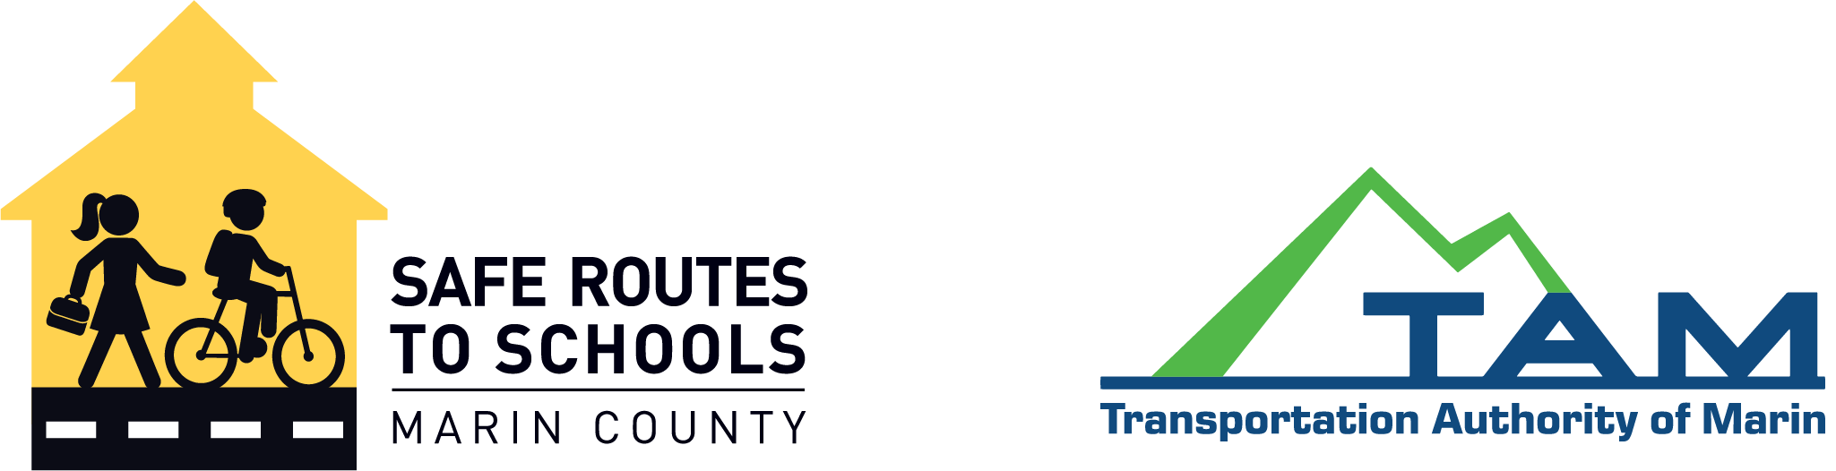
Dear Manager,

Our [school’s name], in partnership with Safe Routes to Schools, will be encouraging walking, biking, and carpooling throughout the 2022-2023 school year. Our actions will help to reduce traffic and make our streets safer while promoting eco-friendly travel alternatives.

To encourage this, we will be hosting contests and weekly welcome tables with incentives for students to participate. Would you please donate a gift certificate from your establishment to be used as a prize?

Safe Routes to Schools is currently working with 50 schools and 20,000 students throughout Marin with a goal of reducing Marin’s carbon footprint and improving health through everyday physical activity.

All in-kind donations are fully tax deductible. Safe Routes to Schools is a program of the Transportation Authority of Marin and implemented by the Marin County Bike Coalition, a [501(c)(3), id#68-0419394 or replace with your school’s tax ID number].

Donations from contributors like you help students realize that our community supports their actions to make a difference. Thank you in advance for your consideration and generosity.

Sincerely,

Your Name
Parent Volunteer
Your Contact Information

Safe Routes to Schools, P.O. Box 695, Fairfax, CA 94978

