**Bike Blender Event**

Give your students a unique experience of blending a smoothie using their own pedal power. The Bicycle Blender teaches students about good nutrition and physical activity all at the same time. Students can take turns powering the blender and everyone shares in the fruits of their labor.

It’s a perfect compliment to a special event, health fair, sustainability program or other special event at your school.

Contact one of our Teen Coordinators to coordinate the use of our Bike Blender. ***Safe Routes to Schools requires that the bike blender be supervised by an adult at all times.***

**Supplies needed:**

The quantities below are based on small cups (5 oz.) tastes. Quantities are based on a one-hour period serving approximately 200 students. You can double the quantities if using larger cups.

What food to get?

1. Frozen fruit: strawberries and raspberries are popular but any frozen fruit works. Get 3 large bags (Costco size), or 6 bags (grocery store size). Often you can keep them frozen in a cooler without ice.

1. Fruit Juice: 3-4 large apple juice containers (Costco size). Cranberry is also good but young children don’t especially like it. If you start running out of juice during an event, add water to it. You can use milk but will have to keep it refrigerated.
2. Bananas: 2 big bundles
3. Cups: Smart and final has small paper cups (cheap) they are so thin that they get soggy but they do work and they are compostable. Or, use 5oz. bathroom cups you can get at Safeway.
4. Other supplies: One roll of paper towels, a long-handled spoon to stir, plastic gloves, a scissor to cut the bags of fruit open, and garbage bags.

**Instructions:**

If you’re serving a large number of students, form two lines. One line is for the students who want to ride the bike blender, and the other line is for those who want to simply get a smoothie.

Have two students stationed at the table filling the blender containers. These students should be wearing gloves if possible. Fill the blender halfway with fruit juice, add half of a banana, and a big handful of frozen fruit. Have another student place the blender on the bike and get a student volunteer to “power” ride the bike.

**Note: Have a volunteer hold the lid of the blender container down while a student is riding/blending.**

If your budget is low, fill the blender halfway, and have multiple kids get on the bike to make the smoothies. This slows down the process.

**Clean-Up:**

Please be sure to clean the stationary stand and take the blender pitchers somewhere you can clean them with hot water – taking all the pieces apart.

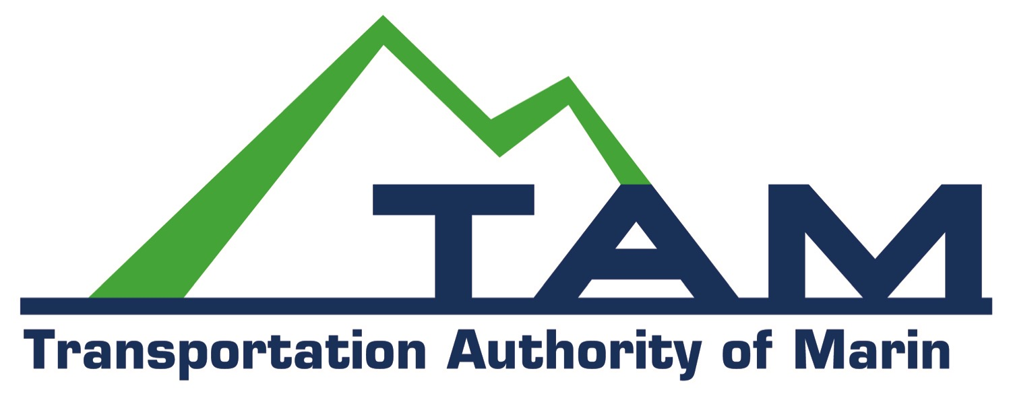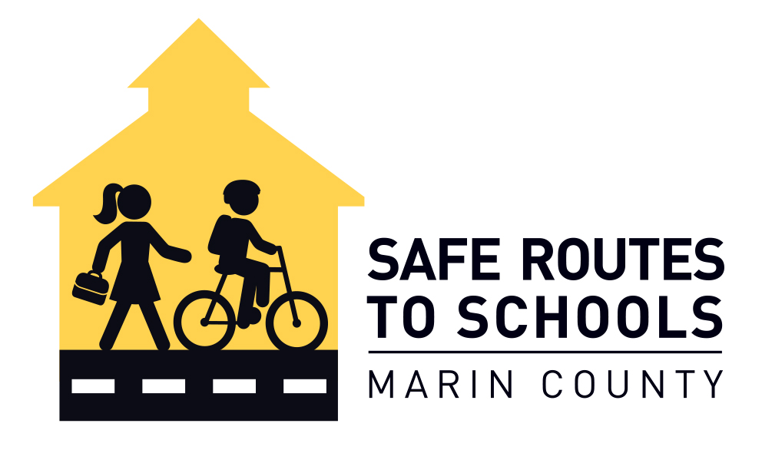***::Documents:Safe Routes :Logos:TeensGoGreen logo.pdf***